New SAT: What will those questions look like?
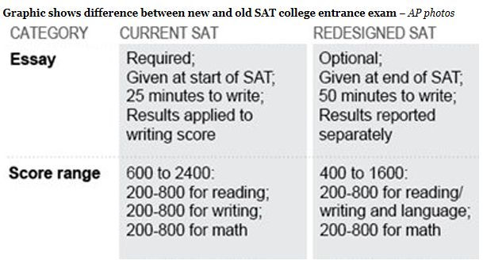
By Kimberly Hefling | Associated Press
Calculate the foreign exchange rate a vacationing American would pay in India. Estimate from a random sample the number of 18- to 34-year olds who voted for a candidate. These are sample questions from the newly redesigned SAT, which aims for more real-world applications and analysis from students.
The College Board released the sample test questions, offering clues to how the revised college entrance exam, taken last year by 1.7 million students, will look when it rolls out in 2016.
One of the biggest changes is that relatively obscure vocabulary words such as "punctilious" and "lachrymose" are unlikely to appear on the test. Test takers will see words more likely to be used in classrooms or in the workplace, like "synthesis."
Instead of a wide range, the math section will concentrate on areas that "matter most for college and career readiness and success," the College Board said.
The essay section is becoming optional. And it now will require a student to read a passage and explain how the author constructed an argument instead of offering the student's own point of view on a specific issue.
Other changes to the SAT, first announced by the College Board last month, include making a computer-based version of the test an option, getting rid of the extra penalty for wrong answers, limiting the use of calculators to select sections and returning to a 1,600-point scale.
Another expectation: Each test will include a passage from the U.S. founding documents, such as the Declaration of Independence, or conversations they've inspired, the College Board has said.
To highlight that, one sample question released was adapted from a 1974 speech by Rep. Barbara Jordan, D-Texas, during the impeachment hearings of President Richard Nixon. Test takers must answer questions that best describe Jordan's stance and the main rhetorical effect of a part of the passage.
In the sample question pertaining to the U.S. traveler in India, the test taker must first determine what foreign exchange rate the traveler paid. Then, calculate charges on a prepaid card compared to a Traveler card.
In the sample question related to a political candidate, the test taker must first determine from a table which age group had the greatest number of people reporting they had voted. Then, compare the table to another survey to determine which of four statements about voter turnout is correct.
Cynthia Schmeiser, the College Board's chief of assessment, told reporters that reasoning is still an important component of the SAT, but it will be done in "applied contexts." She said there will be commonalities between the redesigned SAT and the Common Core standards being rolled out in most states, which emphasize critical thinking in English and math in the K-12 setting.
"What we're doing here is trying to distinguish the SAT in many important ways from the current SAT and frankly from other admissions exams to provide the why and the what are the fewer more important things that students need in order to be ready for college and to succeed in college," Schmeiser said.
The College Board said the sample questions are in draft form and subject to change.
"It is our goal that every student who takes the test will be well informed and will know exactly what to expect on the day of the test," Schmeiser and College Board President David Coleman said in a letter posted online.
The SAT was last upgraded in 2005, when analogy questions were removed and the essay portion was added.
Once the predominant college admissions exam, the SAT has been overtaken in popularity by the ACT.
The ACT, which already offers an optional essay, announced last year that it would begin making computer-based testing available. It said Monday that about 4,000 high school students had taken a digital version of the ACT two days earlier as part of a pilot.
Critical thinking challenge: How much did the ACT motivate the College Board to change the SAT?

